**OOPJ ASSIGNMENT -1**

Q1. Create a program that declares and initializes all primitive data types in Java and prints their default and assigned values.

Q2. Write a program to convert an int value to double automatically and display both values.

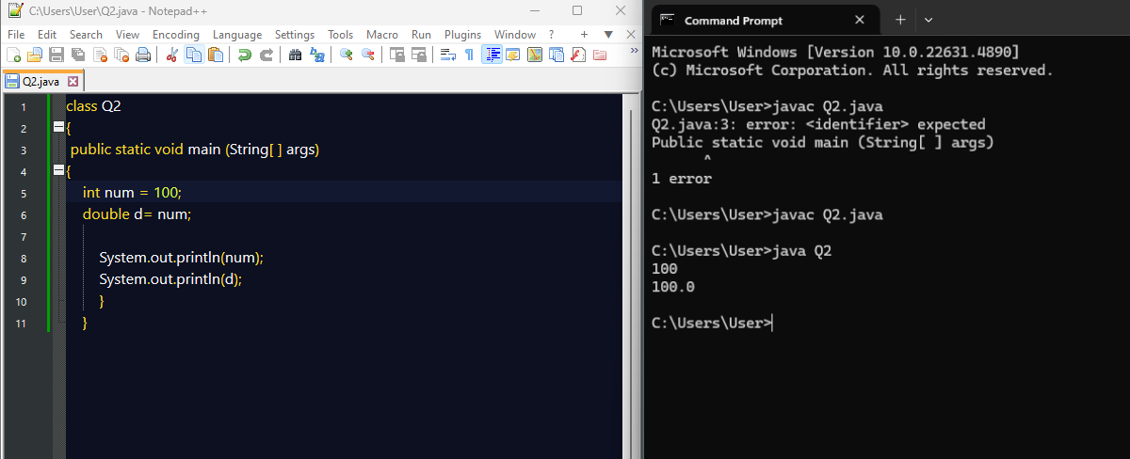

Q3. Write a program to convert a double value to int using typecasting and explain the data loss.

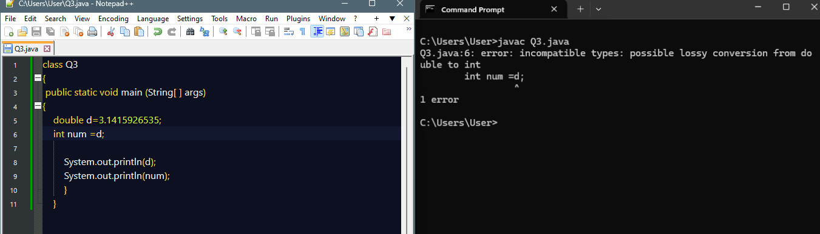

Q4. Write a program to calculate the average of three int numbers using typecasting to display the result in double.

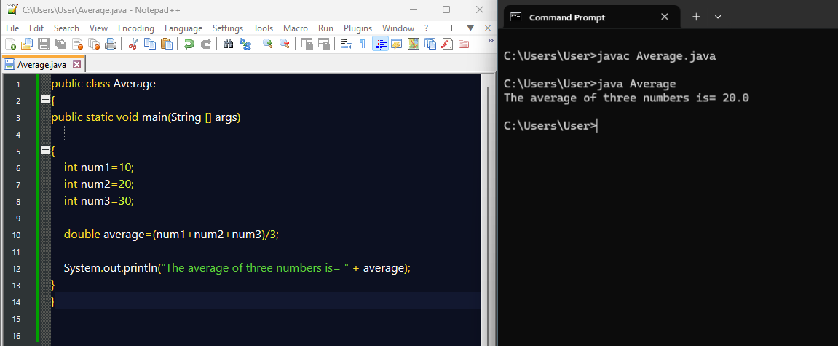

Q5. Write a program to demonstrate binary, octal, hexadecimal, and floating-point literals in Java.

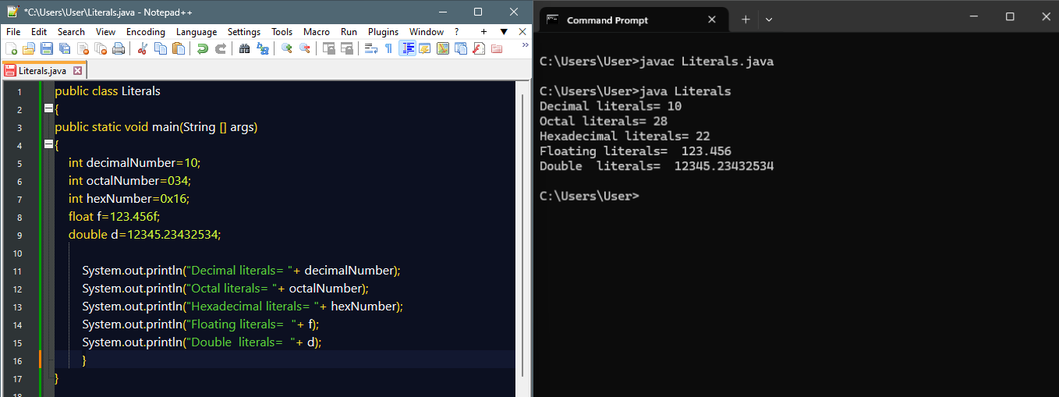

Q6. Write a program to display character and string literals along with their ASCII values.

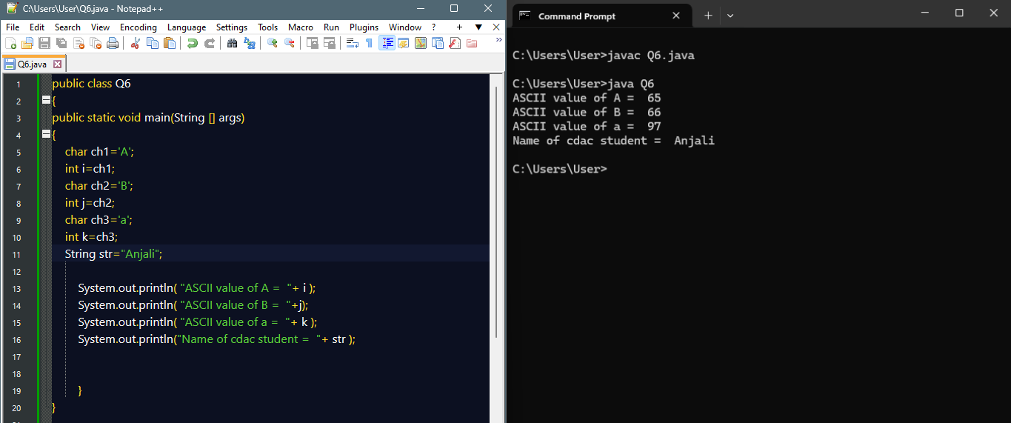

Q7. Write a program that uses boolean literals to control program flow in an if-else statement.

8. Write a program to perform addition, subtraction, multiplication, division, and modulus operations on two integer numbers and display the results.

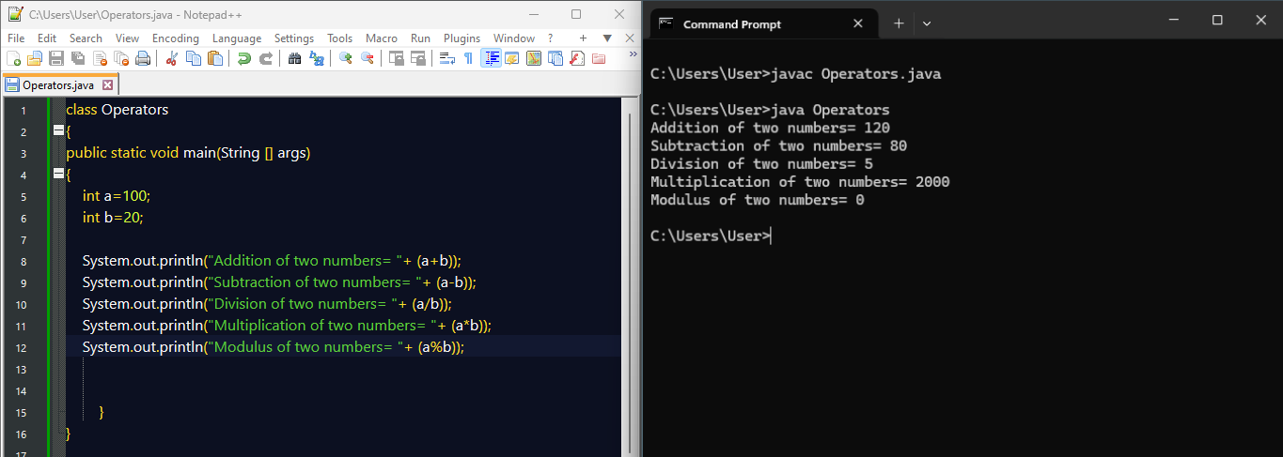

Q9. Write a program to compare two integers using all relational operators (==, !=, >, <, >=, <=) and display the results.

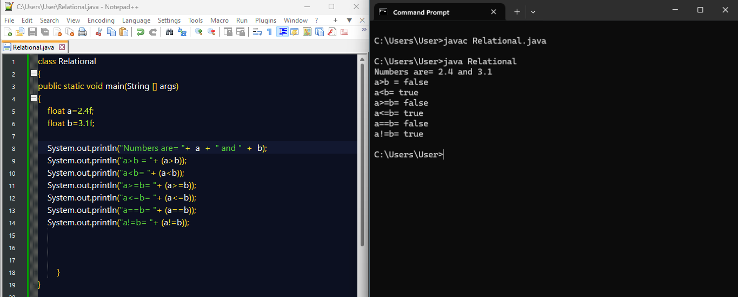

Q10. Write a program to check if a number is positive and even using logical operators (&&, ||, !).

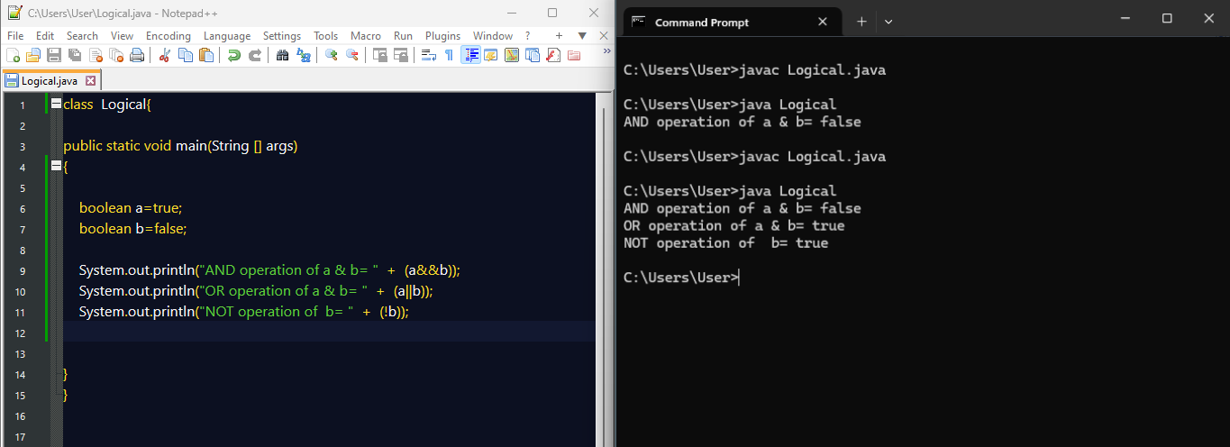

Q11. Write a program to demonstrate the use of assignment operators (=, +=, -=, *=, /=, %=) on two integers.

